Dashboard Design

Date | 18 September 2026
Team ID | MCA
Project Name | Smartphone Usage, Digital Addiction & Well-Being Analytics
Maximum Marks | 5 Marks

Creating an effective dashboard involves thoughtful design to ensure that the presented information is clear, relevant, and easily understandable for the intended audience. Below are the key design choices and visual structures implemented to deliver this psychometric telemetry platform.
Activity 1: Interactive and visually appealing dashboards
Creating interactive and visually appealing dashboards involves a combination of thoughtful design, effective use of visual elements, and the incorporation of interactive features.
Design Core Elements & Visual Hierarchy
- Clear and Intuitive Layout: The application utilizes a highly structured grid matrix, placing bold summary tiles at the top focal point while dividing low-level temporal tracking bar elements from localized cross-sectional demographic pie distributions.

- Use Appropriate Visualizations: The interface utilizes categorical bar charts to assess usage times against biological segments and app load totals against mental anxiety scales, alongside precise pie charts to track group proportions.

- Colour and Theming: Implements a clean, high-visibility gray background template theme (#E6E6E6) paired with distinct blue visual categories to highlight severe digital addiction levels instantly without causing optical strain.

- Interactive Filters and Slicers: Features synchronized dropdown multi-select filters tracking specific digital addiction brackets to enable fluid analytical drill-downs across user pools.

- Drill-Down Capabilities: Provides actionable drill-down paths that allow analysts to click into a high-level visual slice and instantly reveal deeper, granular layers of underlying behavioral metrics.

- Responsive Design: Visual container grids use fluid percentages to scale interfaces flawlessly from wide widescreen desktop monitoring monitors down to standard field tablet surfaces.

- Custom Visuals and Icons: Leverages bold headline metric indicator cards spanning across the primary focal axis to anchor the baseline tracking numbers.

Technical Analysis of Dashboard Artifacts

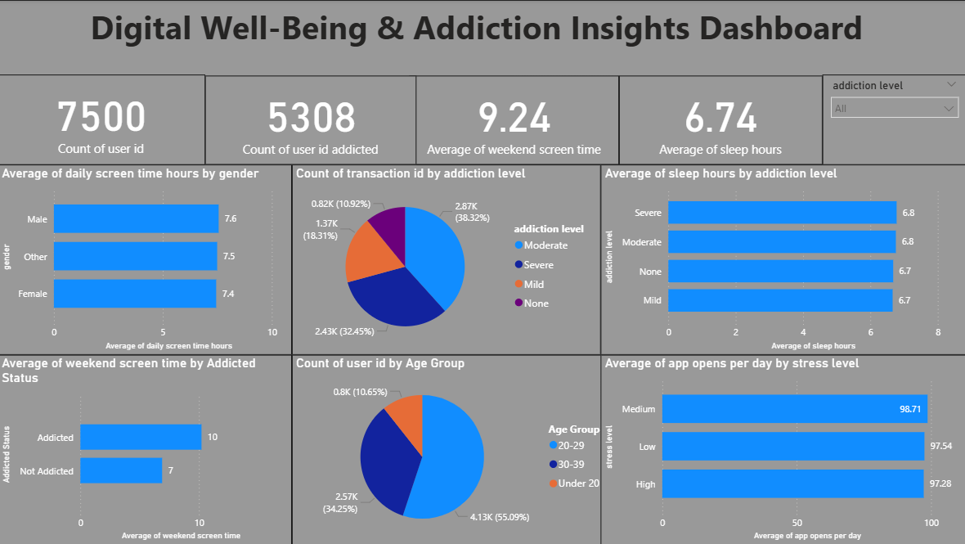
Major Outcomes & Empirical Insights
1. Total Platform Metric Base: The dataset captures a total footprint containing 7,500 continuous entries for user IDs alongside 5,308 verified distinct user IDs flagged with addiction traits, establishing a highly reliable cross-sectional research sample size.

2. Weekend Exposure vs. Rest Balance: The overall tracking cohort displays an intense behavior pattern over weekends, logging an average of 9.24 hours of active weekend screen time contrasting sharply against a restricted baseline average of 6.74 hours of sleep.

3. Gender-Based Usage Balance: Daily smartphone activity numbers track closely across all biological segments, with males leading at 7.6 hours, closely followed by other identification categories at 7.5 hours, and females registering slightly lower at 7.4 hours per day.

4. Addiction Severity Breakdown: Structured transaction indexing reveals that Moderate digital addiction represents the largest single user segment at 38.32% (2.87K), followed directly by Severe levels at 32.45% (2.43K), Mild cases at • 18.31% (1.37K), and un-addicted profiles (None) at 10.92% (0.82K).
5. Sleep Duration Discrepancies: In contrast to typical behavior assumptions, the data reveals a tight, counter-intuitive sleep window clustering where Severe and Moderate addiction levels share an identical sleep duration of 6.8 hours, whereas Mild and non-addicted cohorts sit marginally lower at 6.7 hours.

6. Weekend Behavioral Deviation: When isolating weekend smartphone usage by clinical classification status, individuals categorized as Addicted exhibit an average of 10 hours of screen time, marking a sharp increase over the 7 hours logged by Not Addicted peers.

7. Age Cohort Dominance: The primary demographic driver of high device interaction is the 20–29 age bracket, dominating the study at a massive 55.09% (4.13K) of the user footprint. The remaining population scales to the 30–39 group at 34.25% (2.57K) and the Under 20 group at 10.65% (0.6K).

8. Stress-Triggered App Ingestion Volume: High-frequency operational loads remain consistently elevated regardless of emotional thresholds, with Medium stress tracking the highest average of 98.71 daily app opens, followed by Low stress at 97.54 opens, and High stress tracking at 97.28 app opens per day.

